Api gateway

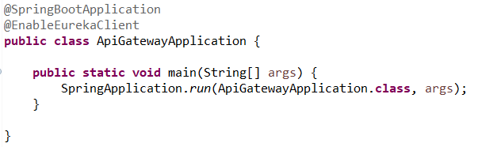

**id** = name of app, **uri** = port/eureka registered name, **predicates** = paths

